Improve Call Flow Exercise: Scheduling a Patient
Take the example call flow below and practice improving it. After you are done, see the solution that we created.

Scheduling an appointment for a patient

When you schedule a doctor’s appointment, you need to make sure that the patient does not have COVID-19. Otherwise, they could infect everybody at the office. So you need to ask a few pre-screening questions such as “Do you have a fever?” and “Do you have a cough?” as well as if they’ve tested positive for COVID-19 recently or if they have recently come into contact with somebody who tested positive for COVID-19.

If they do have, or are at risk of having COVID-19, then they must either wait to be scheduled until they no longer show any symptoms, or they need to be scheduled for a telehealth visit. To do a telehealth visit, you will need to confirm that the appointment is for them. If it is for a family member or for somebody else, then you will need to follow the procedures for scheduling an appointment on behalf of somebody else, which includes having the other person’s permission and insurance information. If it is for them, then you can log into the telehealth website at www.telehealth.com and schedule the appointment.

If the patient does not have, or are not at risk of having COVID-19, then you can schedule them the regular way as long as they are scheduling for themselves. If they are scheduling for another individual, make sure to get that person’s permission. Just make sure that you schedule them for a doctor that takes their insurance and is at a time that the doctor’s schedule is available.

Follow the 4 steps

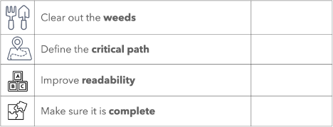

1. Clear out the weeds
- Remove stories and background information

2. Define the "Critical Path"
- Highlight the key actions and decisions
- Write them out as a bulleted list
- Convert decisions into Yes/No questions or multiple choice answers

3. Improve readability
- Could a 10-year old understand it?
- Is it written for a rep or an engineer?
- Use bold, italics, lists, different font colors, etc. to make the actions clear to see
- Make all instructions as brief as possible (e.g. can you use 3 words instead of 10?)

4. Make it complete (while still keeping it readable)
- Do you include what your reps should say?
- Do you include what your reps should ask?
- Do you Include what your reps should do?
- Do you include how your reps should do it?
- Do you include variations for what could happen?

Learn more
- Learn about Zero Memorization Training
- Schedule a free consultation or demo

